INTELLECTUAL PROPERTY RIGHTS CELL

Aim and Purpose | To disseminate knowledge on types of patents, global patent regime, etc to target talents
Aim and Purpose | To encourage faculty members and scholars to go for patentable works
Aim and Purpose | To help faculty members in the nitty-gritty of registration of patents

Name | Designation & Dept./Division/College. | Status
Dr. K. Sankaranarayanan | Professor  Department of Physics | Coordinator
Dr. S. Karutha Pandian | Professor & Head  Department of Biotechnology | Member
Dr.V.Manickavasagam | Professor & Head  Department of Corporate Secretaryship | Member
Dr.P.S.Nagarajan | Assistant Professor  Alagappa Institute of Management | Member

Activities | Organizing workshops to familiarize faculty members and scholars on patents, patent regime in India and abroad and registration aspects
Activities | Providing facilities for faculty and scholars for progressively going for patentable works
Activities | Listing of Patents held by Faculty and others in the University

Activities Carried out
Year | Description of Activity | Date | Participants/  Beneficiaries
2017 | IPR Cell conducted an awareness program on IPR to the scholars of Alagappa University. The coordinator, introduced the IPR Cell to the participants and explains its objectives and the available assistance on IPR to the academicians, researchers and innovators to indentify, protect and manage IPR effectively.  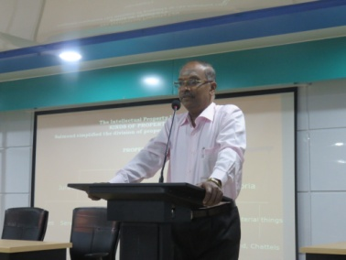  The former Registrar, Dean Management, Professor and Head, Dr.V.Manickavasagam, Dept. of Corporate Secretaryship, Alagappa University delivered the invited talk on ”Intellectual Property Rights – Awareness and Protection”. Dr.M.Ramesh, Associate Professor, Department of Bio-technology, Alagappa University, elaborates the criteria for obtaining Patents in biological related fields. The inventors from the Faculty of Science; Prof.H.Gurumallesh Prabu and Dr.M.Sundrarajan from Department of Industrial Chemistry, Prof.K.Sankaranarayanan, Department of Physics, Prof.K.Balamurugan, Department of Biotechnology and Prof.S.Ravikumar, Department of Oceanography and Coastal area studies briefed their patents that were filed by them. They have explained the background of invention and how distinct from other works with industrial application. The feedback from the audience, ascertain that the program motivated them to think laterally on their research work and look for opportunities to design a patent out of it. | 13.02.2017 | Research Scholars of Alagappa University
2016 | IPR Cell celebrated World Intellectual Property Day at University Convocation Seminar Hall. Professor Dr. S. Karutha Pandian, Former Coordinator of IPR Cell, in his welcome address highlighted the role in of protecting various forms of Intellectual Properties. He appealed to the students to go for innovative research. In his presidential address, Dr. V. Balachandran, Registrar i/c, Alagappa University dwelled on the theme of World Intellectual Property Day 2016 “Digital Creativity: Culture Reimagined” and stressed the importance of new technologies in the digital age.  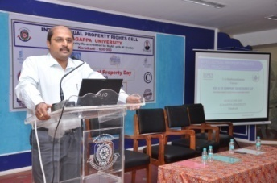  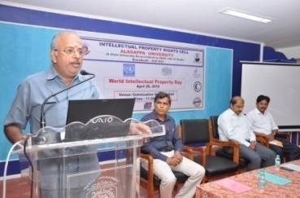  A special lecture entitled “Basic Principles of Different types of Intellectual Property Rights” was delivered by Shri C.V. Madhusudhanan, Partner, KSR &Co, Coimbatore. He explained the significance of Patent, Trade Secret, Trade Mark, and Copy Right. He critically narrated the bottlenecks of getting industrially useful patents and the current problems faced by industries and companies with trade and brand names. | 26.04.2016 | Faculty Members,  Research Scholars and PG Students of the University.
2015 | As part of the IPR day celebration, an IP Awareness Programme was organized in the Seminar Hall, Department of Biotechnology, Science Campus, Alagappa University. Mr. T. Srinivasan, Patent Attorney, Joint Partner & Patent Agent, Lakshmikumaran & Sridharan, Chennai delivered a special lecture covering the following aspects:  1. Basics of IPR - Patents, Trade-marks, Copyrights, Designs, Plant Variety Protection, Biodiversity, 2. Fundamentals of Patents - Rights conferred, Conditions of Patentability, Inventions not patentable, 3. How to read Patent Document?, 4. How to obtain Patent rights in India and PCT / Overseas, 5. Certain land mark cases on Patent litigation and 6. Patent Search. | 07.05.2015 | Faculty Members, Research Scholars and PG Students of the Faculty of Science
2014 | Dr. N.Subramonian, Principal Scientist, Sugarcane Breeding Institute, Coimbatore – 641007 delivered a lecture on “Patenting Biotechnological Inventions” to raise awareness of how patents, copyright, trademarks and designs in the field of biotechnology impact on daily life.  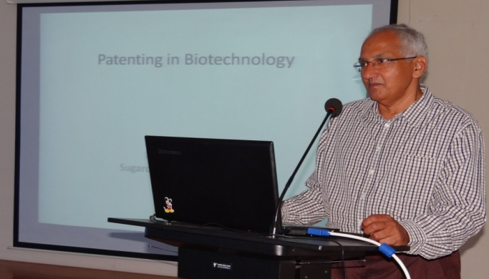 | 26.04.2014 | Faculty Members, Research Scholars and PG Students of the Biosciences Departments of Alagappa University.

Any other
On the initiatives taken by the IPR Cell, Eight claims in 2015 and Three in 2016 have been filed for Indian Patents. The following is the details of the patents generated by Alagappa University, Karaikudi during 2011 to 2016.

Sl.No. | Department | Year | Name Of The Faculty | Application No. | Granted/  Filed | Jurisdiction
1 | Physics | 2016 | Dr.K.Sankara Narayanan | 201641011210 Dt.30/3/2016 | -- | India
1 | Industrial Chemistry | 2016 | Hong Sun Lg, J. Suresh, R.Yuvakkumar, J. Nathanael, M. Sundrarajan | 10-16171994  dt: 27.04.2016 |  | South Korea
2 | Biotechnology | 2016 | Sivasankar C, Pandian SK and Balamurugan K | 201641010057 | -- | India
3 | Biotechnology | 2015 | Sivasankar C, Pandian SK, Gayathri S and Bhaskar JP | 1732/CHE/2015 | Published | India
4 | Biotechnology | 2015 | Sivasankar C, Pandian SK, Gayathri S and Bhaskar JP | 1734/CHE/2015 | Published | India
5 | Biotechnology | 2015 | Prasanth MI, Balamurugan K, Pandian SK, Gayathri S and Bhaskar JP | 676/KOL/2015 | -- | India
6 | Biotechnology - | 2015 | Prasanth MI, Balamurugan K, Pandian SK, Gayathri S and Bhaskar JP | 679/KOL/2015 | -- | India
7 | Biotechnology | 2015 | Prasanth MI, Balamurugan K, Pandian SK, Gayathri S and Bhaskar JP | 677/KOL/2015 | -- | India
8 | Biotechnology | 2015 | Prasanth MI, Balamurugan K, Pandian SK, Gayathri S and Bhaskar JP | 680/KOL/2015 | -- | India
9 | Biotechnology | 2015 | Prasanth MI, Balamurugan K, Pandian SK, Gayathri S and Bhaskar JP | 766/KOL/2015 | -- | India
10 | Biotechnology | 2015 | Prasanth MI, Balamurugan K, Pandian SK, Gayathri S and Bhaskar JP | 779/KOL/2015 | -- | India
11 | Industrial Chemistry | 2014 | M. Sundrarajan, Hong Sun Lg, J. Suresh, R.Yuvakkumar, R. Rajive Gandhi | 3557/CHE/2014A  dt: 20.07.2014 | - | India
12 | Industrial Chemistry | 2013 | Dr.H.Gurumallesh Prabu | 2196/CHE/2013  20.05.2013 | -- | India
13 | Oceanography and Coastal Area Studies  (OCAS) | 2013 | Dr. S. Ravikumar | 2115/CHE/2013 | --- | India
14 | OCAS | 2013 | Dr. S. Ravikumar | 2196/CHE/2013 | -- | India
15 | OCAS | 2013 | Dr. S. Ravikumar | 3390/CHE/2013 | -- | India
16 | Industrial Chemistry | 2012 | Dr.G.Paruthimal Kalaignan  G.A.Pathanjali  M. Nagarajan | 217 /CHE/2011  24 .01.2011 | Granted  44 / 2012 & 02/11/2012 | India
18 | Industrial Chemistry | 2012 | Dr.G.Paruthimal Kalaignan  G.A.Pathanjali  M. Nagarajan | 236 /CHE/ 2011  25.01.2011 | Granted  45 / 2012 &  09/11/2012 | India
